1. **Introduction**

- This shows the rate of freelancing in the United States of America (USA)

2. **Objective**

- This aims to show freelancers availability, gender who are into freelancing and their clients satisfaction rate.

3. **Data Source**

- This dataset was gotten from <https://kaggle.com>

4**. Data Cleaning**

- I created a duplicate which I then started editing

- Changed the header to proper case

- Adjusted the gender column i.e. M - Male, F - Female and I applied proper case

- Adjusted the currency column where USD was changed to "$".

- The "Is Active" column was changed to No or Yes

- I checked for blanks, rows with two or more blank cells were completely removed from my dataset (Listwise deletion)

- Blanks in the "Age column" were filled at random

- Blanks in the "Years Of Experience column" were filled at random

- Blanks in the "Hourly Rate(Usd) column" were filled at random using K-Nearest Neighbors (KNN) imputation

- Blanks in the "Rating column" were filled at random

- Blanks in the "Is Active column" were filled at random

- Blanks in the "Client Satisfaction column" were filled at random\

5. **Analysis**

- Methods: Descriptive Analysis

- Data Exploration: My dataset contains 928 rows of data.

The mean/median/mode imputation could not be used.

6. **Visualizations**

**- Gender Difference**

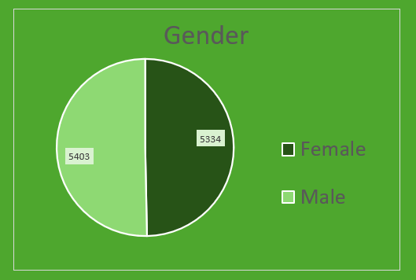

- Client Satisfaction Rate

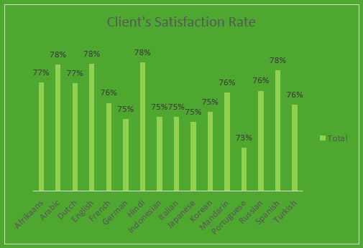

9. **Conclusion**

- Males are more.

- The clients satisfaction rate on an average ranged from 73% - 78%.

-